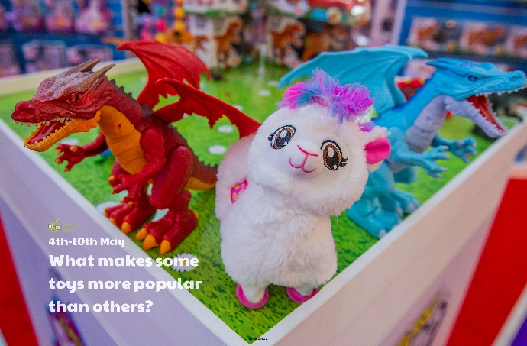

Describe your favourite toy. Think about what it looks and feels like, when and where you got it, how it works or how you use it to play and why it is your favourite toy. Make sure you include a picture of it too!

Research toys from the past and compare with toys we have now. Discuss differences and similarities.

Interview an adult member of your family to find out if the toys they play with have changed over time and why. Jot down some of the questions you might ask before you begin your interview.

Design and make a toy! Decide what you could make using items you already have at home e.g. a tower set, pencil puppets, a shoebox house, a sock soft toy, a car ramp. Be creative! Once you have decided, plan your design carefully: name of your toy, draw a labelled picture of your design, make a list of resources and equipment you will need, think about how you will make it.

Choose five toys and ask people in your home and/or some of your friends or family to select their favourite. The more people you can ask, the better! Once you have your data, can you display it in a bar chart?

**Learning from Home**

Use the ideas below, alongside this week’s resource, to support your home learning.

Create your very own toy shop! You could use toys you have in your home. Decide how much each will cost and put price tags on them and create a price list. See if someone in your home will come and play in your toy shop!