Co-ordinates in four quadrants
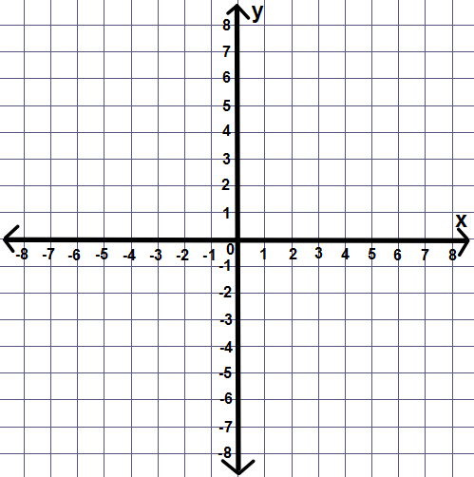
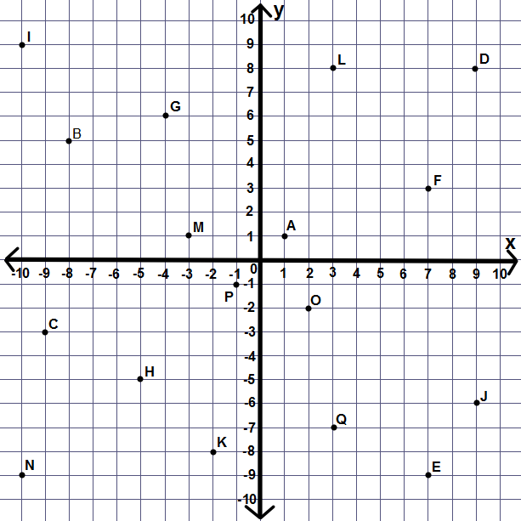
1. Write down the co-ordinates for the points labelled A-Q.
Extension:

3. (-1,3) (5,3)(5,7) are 3 vertices of a rectangle. Plot these points.
a) What is the co-ordinate of the last vertices?
b) What are the co-ordinates of the midpoint of each side? Plot and label each one.
b) What is the co-ordinate of the centre of the rectangle?

4. (-3,4)(-2,1)(-5,0) are 3 vertices of a square. Plot these points.
a) What is the co-ordinate of the missing vertices?
b) What is the co-ordinate of the centre of the square?

5. Plot (-4,-3)(5,-7) and draw a line between them.
Plot (-4,-8)(5,-7) and draw a line between them.
What is the co-ordinate of the point of intersection?
2. Plot the points and join them in order with a straight line.
(4, 6)
(1, 1)
(6, 4)
(4, 0)
(6, -4)
(1, -1)
(4, -6)
(0, -4)
(-4, -6)
(-1, -1)

(-6, -4)
(-4, 0)
(-6, 4)
(-1, 1)
(-4, 6)
(0, 4)
(4, 6)

